The Metronome

EE3376

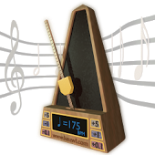By: Marc Villarreal, Luis Santos, Esteban Acosta